# DML

|  |  |
| --- | --- |
| Sr. No | List of Practical Experiments |
| 1 | Write a program to implement Simple Linear Regression |
| 2 | Write a program to implement multiple Linear Regression |
| 3 | Write a program to implement K-nearest Neighbors (K-NN)/SVM |
| 4 | Write a program to implement Naïve Bayse / DT |
| 5 | Write a program to implement K-means clustering. |
| 6 | Write a program to implement Hierarchical clustering. |
| 7 | Write a program to build ANN. |
| 8 | Write a program to build CNN. |
| 9 |  |
| 10 |  |

**Practical 1**

**Aim:** Write a program to implement Simple Linear Regression

# Code:

import numpy as np

import matplotlib.pyplot as plt import pandas as pd

dataset = pd.read_csv("Salary_Data.csv")

X = dataset.iloc[ : , : -1].values y = dataset.iloc[ : , -1].values

print(X) print("\n\n\n") print(y)

from sklearn.model_selection import train_test_split

X_train, X_test, y_train, y_test = train_test_split(X, y, test_size = 1/4, random_state = 0)

print(X_train) print("\n\n\n") print(X_test) print("\n\n\n") print(y_train) print("\n\n\n") print(y_test)

from sklearn.linear_model import LinearRegression linear_regression = LinearRegression() linear_regression.fit(X_train, y_train)

y_train_pred = linear_regression.predict(X_train) y_test_pred = linear_regression.predict(X_test)

plt.scatter(X_train, y_train, color = "green", marker = "+", label = "Observed data") plt.plot(X_train, y_train_pred, color = "red", label = "Predicted data") plt.xlabel("Years of experience")

plt.ylabel("Salary")

plt.title("Years of experience v/s Salary (Training dataset)") plt.legend()

plt.show()

plt.scatter(X_test, y_test, color = "green", marker = "+", label = "Observed data") plt.plot(X_test, y_test_pred, color = "red", label = "Predicted data") plt.xlabel("Years of experience")

plt.ylabel("Salary")

plt.title("Years of experience v/s Salary (Testing dataset)")

plt.legend() plt.show()

# Output:

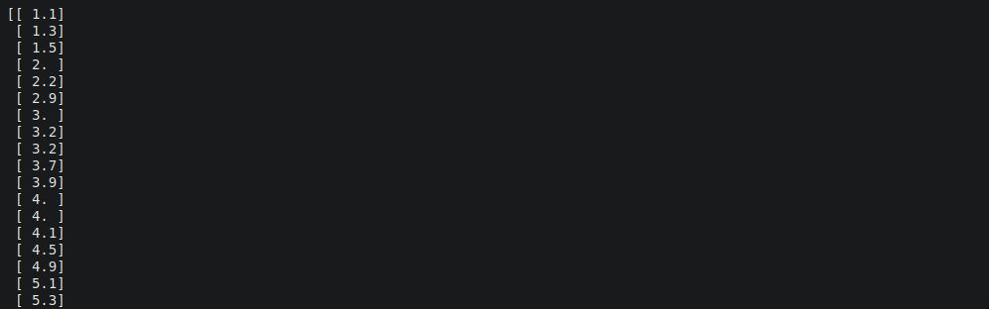

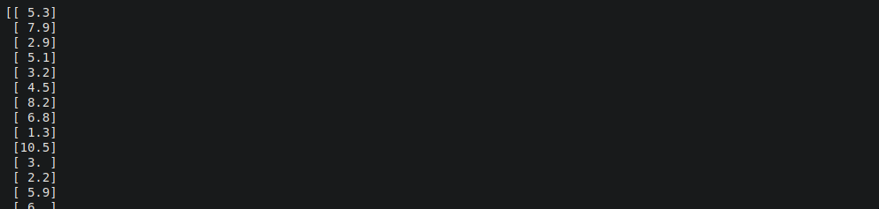

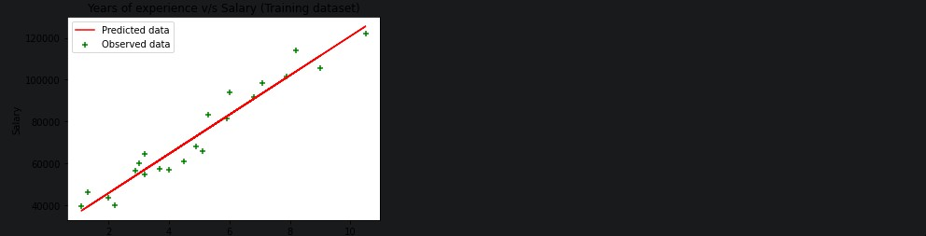

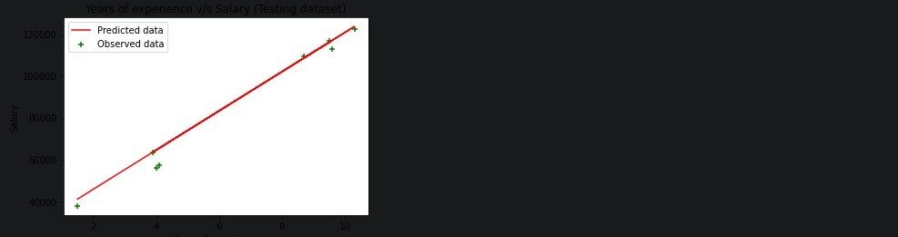

**Practical 2**

**Aim:** Write a program to implement multiple Linear Regression

# Code:

import numpy as np

import matplotlib.pyplot as plt import pandas as pd

dataset = pd.read_csv('/content/50_Startups-2.csv') x = dataset.iloc[:, :-1].values

y = dataset.iloc[:, -1].values print(x)

print(y)

from sklearn.compose import ColumnTransformer from sklearn.preprocessing import OneHotEncoder

ct = ColumnTransformer(transformers=[('encoder', OneHotEncoder(), [3])], remainder='passthrough')

x = np.array(ct.fit_transform(x)) print(x)

from sklearn.model_selection import train_test_split

x_train, x_test, y_train, y_test = train_test_split(x, y, test_size=0.2, random_state=0)

from sklearn.linear_model import LinearRegression regressor = LinearRegression() regressor.fit(x_train, y_train)

y_pred = regressor.predict(x_test) np.set_printoptions(precision=2)

print(np.concatenate((y_pred.reshape(len(y_pred),1), y_test.reshape(len(y_test),1)),1))

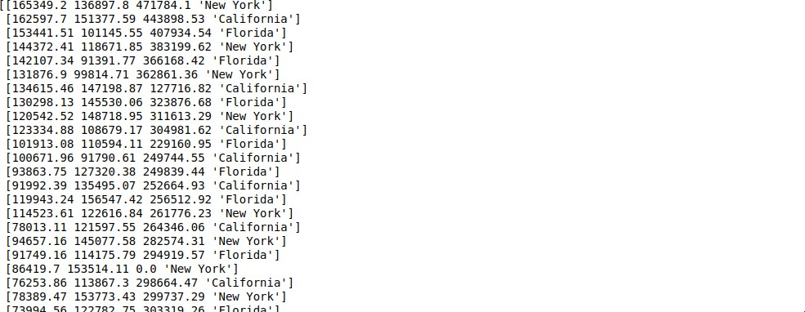

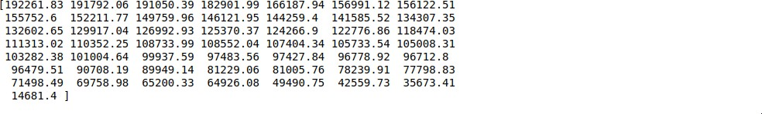

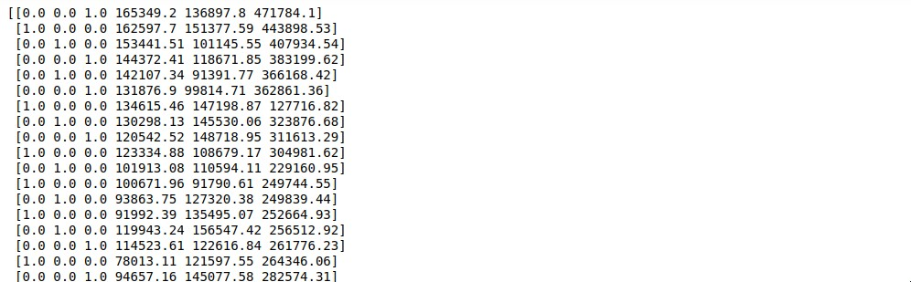

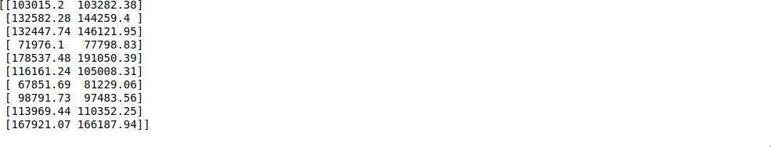

# Practical 3

**Aim:** Write a program to implement K-nearest Neighbors (K-NN)/SVM

# Code:

import matplotlib.pyplot as plt import numpy as np

import pandas as pd

dataset = pd.read_csv('/content/Social_Network_Ads.csv') x = dataset.iloc[:, :-1].values

y = dataset.iloc[:, -1].values print(x)

print(y)

from sklearn.model_selection import train_test_split

x_train, x_test, y_train, y_test = train_test_split(x, y, test_size=0.25, random_state=0) print(x_train)

print(y_train) print(x_test) print(y_test)

from sklearn.preprocessing import StandardScaler sc = StandardScaler()

x_train = sc.fit_transform(x_train) x_test = sc.transform(x_test)

print(x_train) print(x_test)

from sklearn.svm import SVC

classifier = SVC(kernel='linear', random_state=0) classifier.fit(x_train, y_train)

print(classifier.predict(sc.transform([[30,200000]]))) y_pred = classifier.predict(x_test)

print(np.concatenate((y_pred.reshape(len(y_pred),1), y_test.reshape(len(y_test),1)),1))

from sklearn.metrics import confusion_matrix, accuracy_score cm = confusion_matrix(y_test, y_pred)

print(cm) accuracy_score(y_test, y_pred)

# Output:

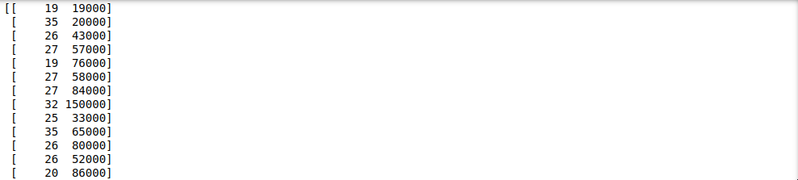

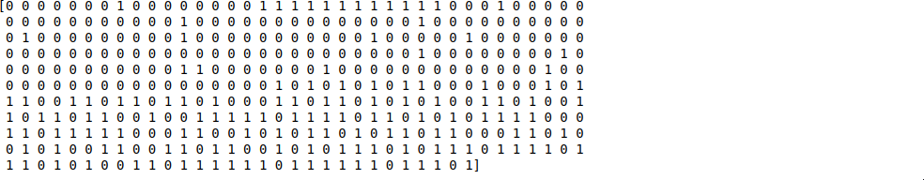

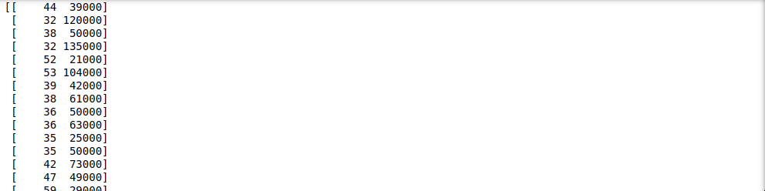

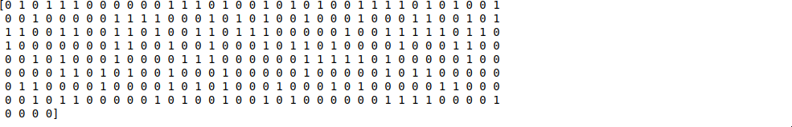

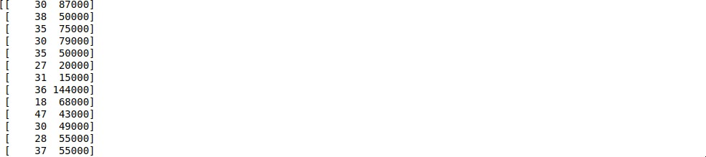



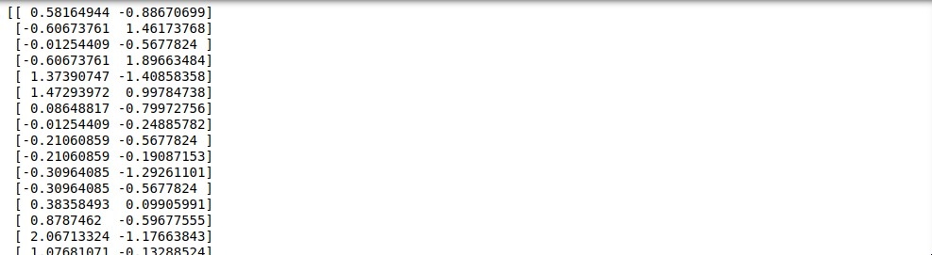

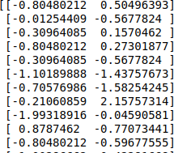



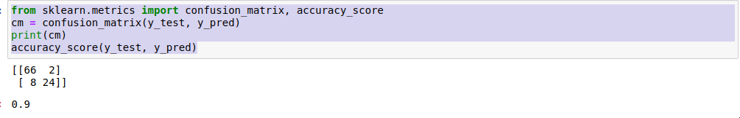

**Practical 4**

**Aim:** Write a program to implement Naïve Bayse / DT

# Code:

import matplotlib.pyplot as plt import pandas as pd

import numpy as np

dataset = pd.read_csv('/content/Social_Network_Ads.csv') x = dataset.iloc[:, :-1].values

y = dataset.iloc[:, -1].values print(x)

print(y)

from sklearn.model_selection import train_test_split

x_train, x_test, y_train, y_test = train_test_split(x, y, test_size=0.25, random_state=0) print(x_train)

print(y_train) print(x_test) print(y_test)

from sklearn.preprocessing import StandardScaler sc = StandardScaler()

x_train = sc.fit_transform(x_train) x_test = sc.transform(x_test)

print(x_train) print(x_test)

from sklearn.neighbors import KNeighborsClassifier

classifier = KNeighborsClassifier(n_neighbors=5, metric='minkowski', p=2) classifier.fit(x_train, y_train)

print(classifier.predict(sc.transform([[40, 200000]]))) y_pred = classifier.predict(x_test)

print(np.concatenate((y_pred.reshape(len(y_pred),1), y_test.reshape(len(y_test),1)),1)) from sklearn.metrics import confusion_matrix, accuracy_score

cm = confusion_matrix(y_test, y_pred) print(cm)

accuracy_score(y_test, y_pred)

# Output:

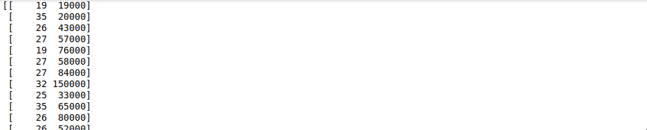

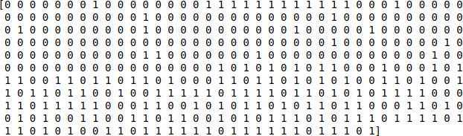

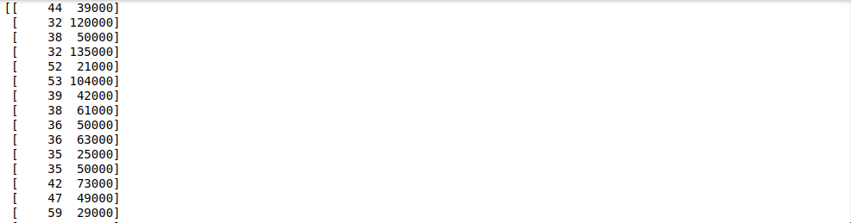

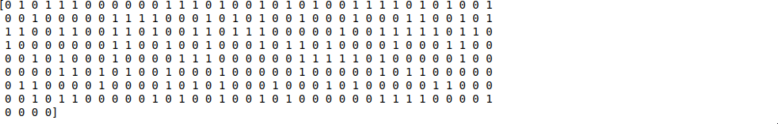

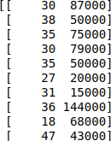



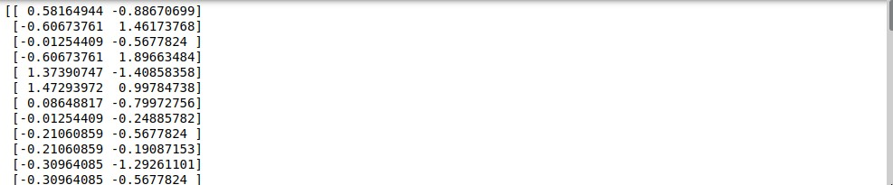

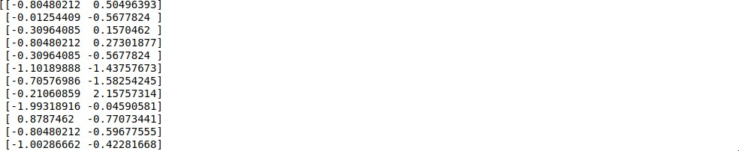

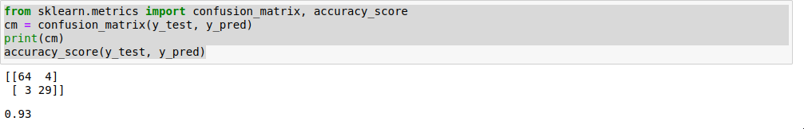

**Practical 5**

**Aim:** Write a program to implement K-means clustering.

# Code:

import numpy as np import pandas as pd

import matplotlib.pyplot as plt

dataset = pd.read_csv('/content/Mall_Customers.csv')

X = dataset.iloc[:, [3,4]].values print(X)

from sklearn.cluster import AgglomerativeClustering

hc = AgglomerativeClustering(n_clusters=5, affinity='euclidean', linkage='ward') y_hc = hc.fit_predict(X)

print(y_hc)

plt.scatter(X[y_hc==0,0], X[y_hc==0,1], s=100, c='red', label='Cluster 1') plt.scatter(X[y_hc==1,0], X[y_hc==1,1], s=100, c='green', label='Cluster 2') plt.scatter(X[y_hc==2,0], X[y_hc==2,1], s=100, c='blue', label='Cluster 3') plt.scatter(X[y_hc==3,0], X[y_hc==3,1], s=100, c='cyan', label='Cluster 4') plt.scatter(X[y_hc==4,0], X[y_hc==4,1], s=100, c='magenta', label='Cluster 5') plt.title('Clusters of customers')

plt.xlabel('Annual Income (k$)') plt.ylabel('Spending Score (1-100)') plt.legend()

plt.show()

# Output:

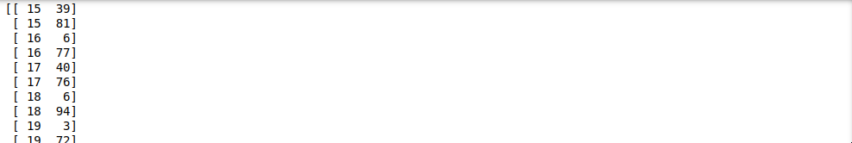

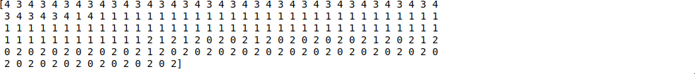

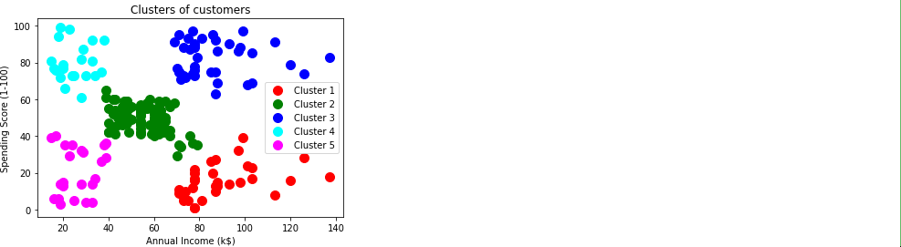

**Practical 6**

**Aim:** Write a program to implement Hierarchical clustering.

# Code:

import numpy as np

import matplotlib.pyplot as plt import pandas as pd

dataset = pd.read_csv('Mall_Customers.csv')

X = dataset.iloc[:, [3, 4]].values

from sklearn.cluster import KMeans

kmeans = KMeans(n_clusters = 5, init = 'k-means++', random_state = 42) y_kmeans = kmeans.fit_predict(X)

print(y_kmeans)

plt.scatter(X[y_kmeans == 0, 0], X[y_kmeans == 0, 1], s = 100, c = 'red', label = 'Cluster 1')

plt.scatter(X[y_kmeans == 1, 0], X[y_kmeans == 1, 1], s = 100, c = 'blue', label = 'Cluster 2')

plt.scatter(X[y_kmeans == 2, 0], X[y_kmeans == 2, 1], s = 100, c = 'green', label = 'Cluster 3')

plt.scatter(X[y_kmeans == 3, 0], X[y_kmeans == 3, 1], s = 100, c = 'cyan', label = 'Cluster 4')

plt.scatter(X[y_kmeans == 4, 0], X[y_kmeans == 4, 1], s = 100, c = 'magenta', label = 'Cluster 5') plt.scatter(kmeans.cluster_centers_[:, 0], kmeans.cluster_centers_[:, 1], s = 300, c = 'yellow', label = 'Centroids')

plt.title('Clusters of customers') plt.xlabel('Annual Income (k$)') plt.ylabel('Spending Score (1-100)') plt.legend()

plt.show()

# Output:

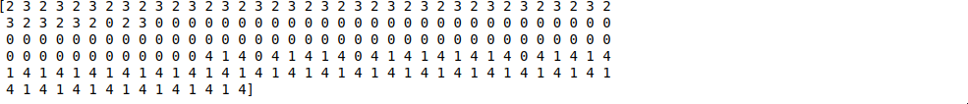

**Practical 7** 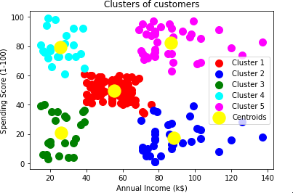 **Aim:** Write a program to build ANN.

# Code:

import numpy as np import pandas as pd import tensorflow as tf

dataset = pd.read_csv('Churn_Modelling.csv')

X = dataset.iloc[:, 3:-1].values y = dataset.iloc[:, -1].values

print(X) print(y)

from sklearn.preprocessing import LabelEncoder le = LabelEncoder()

X[:, 2] = le.fit_transform(X[:, 2]) print(X)

from sklearn.compose import ColumnTransformer from sklearn.preprocessing import OneHotEncoder

ct = ColumnTransformer(transformers=[('encoder', OneHotEncoder(), [1])], remainder='passthrough')

X = np.array(ct.fit_transform(X)) print(X)

from sklearn.model_selection import train_test_split

X_train, X_test, y_train, y_test = train_test_split(X, y, test_size = 0.2, random_state = 0)

from sklearn.preprocessing import StandardScaler sc = StandardScaler()

X_train = sc.fit_transform(X_train) X_test = sc.transform(X_test)

ann = tf.keras.models.Sequential() ann.add(tf.keras.layers.Dense(units=6, activation='relu')) ann.add(tf.keras.layers.Dense(units=6, activation='relu')) ann.add(tf.keras.layers.Dense(units=1, activation='sigmoid'))

ann.compile(optimizer = 'adam', loss = 'binary_crossentropy', metrics = ['accuracy']) ann.fit(X_train, y_train, batch_size = 32, epochs = 100) print(ann.predict(sc.transform([[1, 0, 0, 600, 1, 40, 3, 60000, 2, 1, 1, 50000]])) >0.5)

y_pred = ann.predict(X_test) y_pred = (y_pred > 0.5)

print(np.concatenate((y_pred.reshape(len(y_pred),1), y_test.reshape(len(y_test),1)),1))

from sklearn.metrics import confusion_matrix, accuracy_score cm = confusion_matrix(y_test, y_pred)

print(cm) accuracy_score(y_test, y_pred)

# Output:

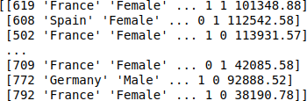



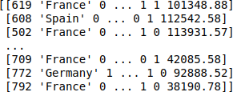

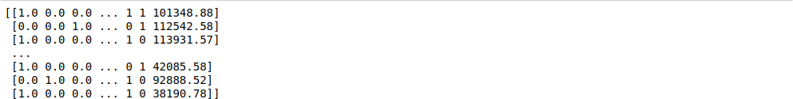

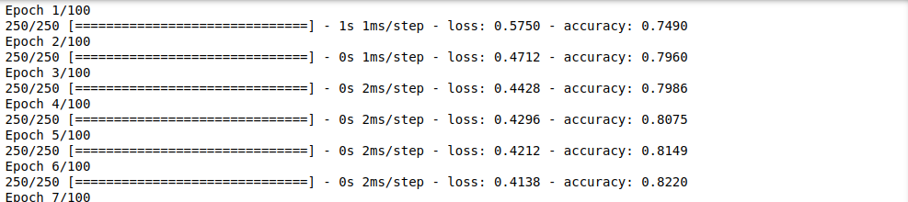

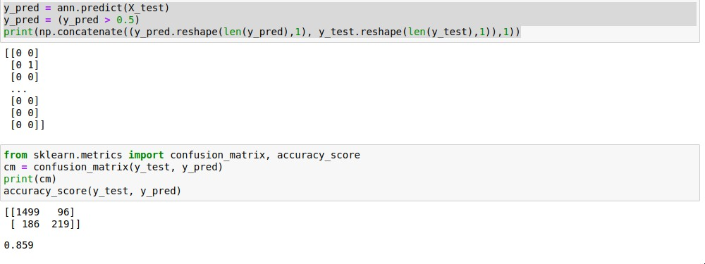

**Practical 8**

**Aim:** Write a program to build CNN.

# Code:

import tensorflow as tf

from keras.preprocessing.image import ImageDataGenerator

train_datagen = ImageDataGenerator(rescale=1./255, shear_range=0.2, zoom_range=0.2, horizontal_flip=True)

training_set = train_datagen.flow_from_directory('/content/drive/MyDrive/small_dataset/training_set', target_size=(64,64), batch_size=32, class_mode='binary')

train_datagen = ImageDataGenerator(rescale=1./255, shear_range=0.2, zoom_range=0.2, horizontal_flip=True)

test_set = train_datagen.flow_from_directory('/content/drive/MyDrive/small_dataset/test_set', target_size=(64,64), batch_size=32, class_mode='binary')

cnn = tf.keras.models.Sequential()

cnn.add(tf.keras.layers.Conv2D(filters=32, kernel_size=3, activation='relu', input_shape=[64,64,3]))

cnn.add(tf.keras.layers.MaxPool2D(pool_size=2, strides=2))

cnn.add(tf.keras.layers.Conv2D(filters=32, kernel_size=3, activation='relu')) cnn.add(tf.keras.layers.MaxPool2D(pool_size=2, strides=2))

cnn.add(tf.keras.layers.Flatten()) cnn.add(tf.keras.layers.Dense(units=128, activation='relu')) cnn.add(tf.keras.layers.Dense(units=1, activation='sigmoid'))

cnn.compile(optimizer='adam', loss='binary_crossentropy', metrics=['accuracy']) cnn.fit(x=training_set, validation_data=test_set, epochs=25)

import numpy as np

from keras.preprocessing import image test_image=image.load_img('/content/drive/MyDrive/small_dataset/single_prediction/cat_or_dog_1

.jpg', target_size=(64,64)) test_image=image.img_to_array(test_image) test_image=np.expand_dims(test_image, axis=0) result=cnn.predict(test_image) training_set.class_indices

if result[0][0]==1: prediction='dog' else: prediction='cat'

print(prediction)

# Output:

